**ISEM 3006 Data Management in Business**

**Exercise 4**

**SQL SELECT**

**Answers (ALL)**

**Use the Trustful Property Rental Company Database in Exerice 3.**

**Use PostgreSQL Select statement to answer the following queries.**

**Unless state otherwise, the case of strings is important, i.e. if I ask you to retrieve properties that are located in 'KLN', you only retrieve properties that are located in 'KLN', but not 'kln', 'Kln', 'kLn', etc.**

**The ordering of the rows is not important, unless I ask you to sort the output**

1. Similare to Q12 in Exercise 3, for each client, list out the client number, client name, and the number of properties that he/she has viewed. (Note that a client may view a property more than 1 times.)

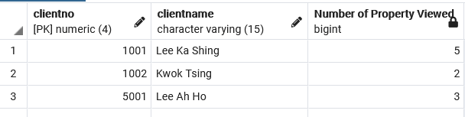

SELECT C.Clientno, C.ClientName,

COUNT(DISTINCT PropertyNo) as "Number of Property Viewed"

FROM Viewing V JOIN Client C

ON V.ClientNo = C.ClientNo

GROUP BY C.ClientNo, C.ClientName ;

/* As C.ClientNo is the primary key of the Client Table

So you can project C.ClientName eventhough it is not included

in the GROUP BY clause. The following will work in PostgreSQL */

SELECT C.Clientno, C.ClientName,

COUNT(DISTINCT PropertyNo) as "Number of Property Viewed"

FROM Viewing V JOIN Client C

ON V.ClientNo = C.ClientNo

GROUP BY C.ClientNo ;

1. List the owner number and name of the property owners whose properties have been viewed in June 2020. Order the output by owner’s name and remove any duplication.

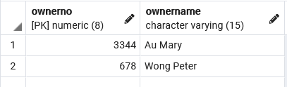

SELECT DISTINCT PO.OwnerNo, PO.OwnerName

FROM Viewing V JOIN Property P

ON V.PropertyNo = P.PropertyNo

JOIN PropertyOwner PO

ON P.OwnerNo = PO.OwnerNo

WHERE TO_CHAR(ViewDateTime, 'MON-YYYY') = 'JUN-2020'

ORDER BY PO.OwnerName;

1. List the owner number and name of the property owners who have listed properties which is taking care of by employee belongs to a branch loacated at the city ‘NT’ and the employee has been hired by the company more than 365 days (when the query is executed).

SELECT PO.OwnerNo, PO.OwnerName

FROM Property P JOIN PropertyOwner PO

ON P.OwnerNo = PO.OwnerNo

JOIN EMPLOYEE E

ON P.EmployeeID = E.EmployeeID

JOIN Branch B

ON E.BranchCode = B.BranchCode

WHERE BranchCity = 'NT'

AND CURRENT_DATE - DateHired > 365;